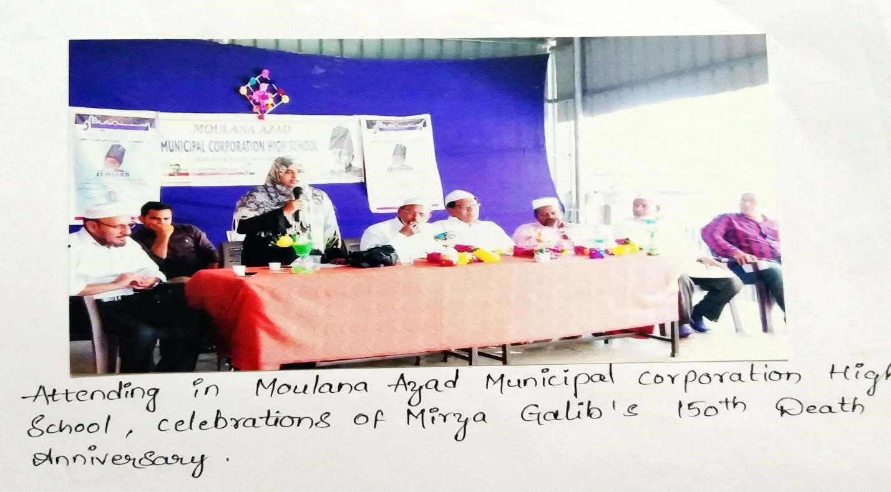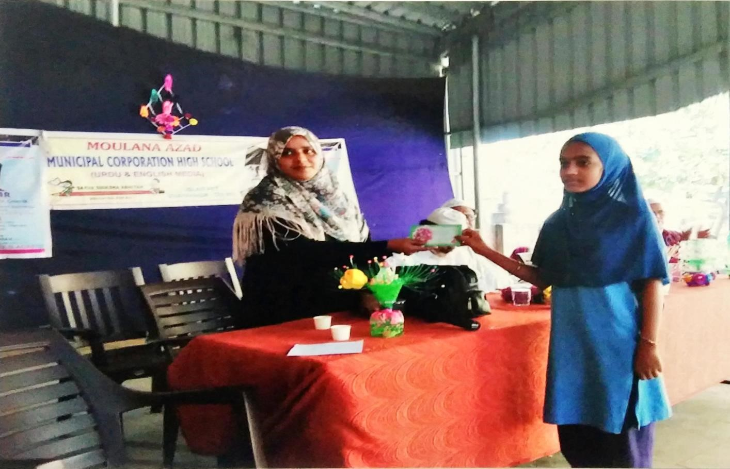

1. **College to school**

|  |  |
| --- | --- |
| **Dates** | **11.11.2020** |
| **Conducted through** **(URDU Departments etc.** | **Department** |
| **Nature of activity** **(seminar//Extn.**  **Lecture etc.** | **Extension activity** |
| **Title of the Activity** | **College to School** |
| **Name of the Department/Committee** | **Department of Urdu** |
| **Details of Resource Persons** **(Name , Designation etc., )** | **Department of Urdu Faculty** |
| **No of students participated** | 200 |
| **Name of the Lecturers who**  **planned & conducted the** **activity** | **Planned and Organized by**  **Mrs Aftoz begum , Lecturer In Urdu**  **Mrs Sd Rasiqa Gathima, Lecturer in History**  **Mr, Abdul Qhoudoos,Lecturer in Political science**  **Ms Dilshad, Lecturer in Economics** |
| **Remarks** | **This activity successfully conducted and reached its objectives** |

|  |  |
| --- | --- |
|  | **Department of Urdu SRR & CVR Govt College Organized college to School , an extension activity on National Education day.**  **Motive of this program:**   * **To provide Urdu exposure to school students** * **To enhance subject matter and Develop Urdu teachings** * **For college students exploring school students college education experiences may enhance student understanding of specific urdu language facts and concepts .** * **may promote a school student’s ability to identify questions and concepts that guide scientifically** * **Cultivating interest in urdu Medium and interest in learning life skills.**   **Report of the activity :**  **SRR and CVR Govt Degree College Dept of Urdu Organized National education DAY on 11-11-2018-21. Faculty members contacted Government Schools namely “tMaulana Azad Urdu school** **c from From panja centre area and requested School Headmasters to send the school students to visit laboratories in your school increases in Minorities awareness in students .**  **Head of the Schools accepted the request and sent nearly 200 students of VIII, IX and X Class Students by 10.30 am to school seminor ground**  **Phed of the department AFROZ BEGUM lecture in urdu addressed the school students initially and explained to them about the Significance of National education Day . She explained to them about the importance of urdu education Discoveries and the Role of poet’s in Day to Day Human Life .**  **In this event various Urdu Departments like language urdu , history , economic, political science , Participated . Concerned Department incharges and , and teachers explained about their subject significance , Important scientific contributions , to High school students .**  **Later all 200 students from schools formed into batches class wise and visited all Department lone by one accompanied by their teachers .** |

